Pursuant to Article 7 paragraph 2 of the Railway Safety Law (”Official Gazette of the RS”, No 41/18),
the Acting Director of the Directorate for Railways has adopted

RULEBOOK

ON A COMMON SAFETY METHOD FOR MONITORING OF THE EFFECTIVENESS OF THE SAFETY MANAGEMENT DURING EXPLOITATION AND MAINTENANCE OF THE RAILWAY SYSTEM

Article 1

This rulebook sets out a common safety method for monitoring of the effectiveness of the safety management during exploitation and maintenance of the railway system.

Article 2

The terms used in this rulebook shall mean as follows:
1) monitoring means the set of measures taken by railway undertakings, infrastructure managers and entities in charge of maintenance to check their management system is correctly applied and effective;
2) management system means the safety management system of a railway undertaking and an infrastructure manager or the system of maintenance of an entity in charge of maintenance;
3) interface means all points of interaction during the lifecycle of a system or subsystem, including its use and maintenance where the different participants in the railway sector cooperate to manage the risks.

Article 3

The common safety method from Article 1 of this rulebook shall be applied by railway undertakings and infrastructure managers after the issuance of a safety certificate or safety authorisation, as well as by entities in charge of maintenance.
The common safety method from Article 1 of this rulebook shall be applied to:
1) check the correct application and effectiveness of all processes and procedures in the management system, including the technical, operational and organisational risk control measures. In case of railway undertakings and infrastructure managers, checking shall include the technical, operational and organisational elements that are necessary for the issue of the safety certificate, i.e. safety authorisation in accordance with the law regulating railway safety and interoperability;
2) check the correct application of the management system as a whole and if the management system achieves the expected outcomes;
3) identify and implement appropriate preventive, corrective or both types of measures if any non-compliance with points 1 and 2 of this paragraph is detected.

Article 4

A railway undertaking, an infrastructure manager or entity in charge of maintenance shall:
1) apply the monitoring process whose elements have been set out in Annex 1, which is joint to this rulebook and forms its integral part;
2) shall monitor the risk control measures implemented by their contractors or require their contractors to apply this process through contractual arrangements;
The monitoring process shall contain the following activities :
1) the definition of a strategy, priorities and plan(s) for monitoring;
2) the collection and analysis of information;
3) the drawing up of an action plan for instances of non-compliances with the requirements laid down in the management system which are unacceptable from the aspect of safety;
4) the implementation of the action plan, if such a plan is drawn up;
5) the evaluation of the effectiveness of action plan measures, if such a plan is drawn up.
The process of monitoring shall be repeated as shown in the diagram in Annex 2, which is joint to this rulebook and forms its integral part.

Article 5

Railway undertakings, infrastructure managers and entities in charge of maintenance, including their contractors shall ensure through contractual arrangements that any relevant safety-related information resulting from applying the monitoring process laid down in Annex 1 of this rulebook is exchanges between them, to enable the other party to take any necessary corrective measures to ensure continuous achievement of the safety performance of the railway system.
If, through the application of the monitoring process, railway undertakings, infrastructure managers or entities in charge of maintenance identify any safety risks as regards defects and construction non- conformities or malfunctions of technical equipment, including those of structural sub-systems, they shall report those risks to the other parties involved (manufacturers, contractors and subcontractors, maintenance entities etc) ti enable them to take any necessary corrective measures to ensure continuous achievement of the safety performance of the railway system.

Article 6

The Rulebook on a Common Safety Method for monitoring of the effectiveness of the safety management during exploitation and maintenance of the railway system (“Official Gazette of the RS”, No 80/15) shall be repealed with effect from the date of entry into force of this rulebook.

Article 7

This rulebook shall enter into force on the eighth day from the day of its publication in the ˮOfficial Gazette of the Republic of Serbiaˮ.

No 340-1062/2020
In Belgrade, 5 October 2020
Acting Director

Lazar Mosurović

Annex 1.

ELEMENTS OF THE MONITORING PROCESS

1. Input data

The input data of the monitoring process shall be all the processes and procedures contained in the management system, including technical, operational and organisational risk control measures.

2. Definition of a strategy, priorities and plan(s) for monitoring

2.1. Based on their management system, each railway undertaking, infrastructure manager and entity in charge of maintenance shall define its strategy, priorities and plan(s) for monitoring.

2.2. The decision on what to prioritise shall take into account information from areas that give rise to the greatest number of risks and which, if not monitored effectively, could lead to adverse consequences for safety. An order of priority for monitoring activities shall be set, and the time, effort and resources required shall be indicated. Prioritisation shall also take into account results from previous applications of the monitoring process.

2.3. The monitoring process shall identify as early as possible instances of non-compliance in the application of the management system that might result in accidents, incidents and other dangerous occurrences. It shall lead to the implementation of certain measures to remedy such instances of non-compliance.

2.4. The monitoring strategy and plan(s) shall define quantitative and/or qualitative indicators that can:
1) give early warnings of any deviation from the expected outcome or assurance that the expected outcome is achieved as planned;
2) give information about unwanted outcomes;
3) support decision making.

3. Collection and analysis of information

3.1. Collection and analysis of information shall be carried out according to the strategy, priorities and plan(s) defined for the monitoring.

3.2. For each defined indicator referred to in point 2.4. of this Annex the following activities shall be carried out:
1) a collection of necessary information;
2) an evaluation as to whether the processes, procedures, technical, operational and organisational risk control measures are correctly implemented;
3) a check on whether the processes, procedures, technical, operational and organisational risk control measures are effective and whether they achieve the expected outcomes;
4) an evaluation of whether the management system as a whole is correctly applied and whether it achieves the expected outcomes;
5) analysis and evaluation of instances of identified non-compliances with points 2 to 4, as well as identification of their causes.

4. Drawing up of an action plan

4.1. For identified instances of non-compliance that are considered unacceptable from the safety aspect, an action plan shall be drawn up which shall:
1) lead to the enforcement of correctly implemented processes, procedures, technical, operational and organisational risk control measures;
2) improve existing processes, procedures, technical, operational and organisational risk control measures;
3) identify and implement additional risk control measures.

4.2. The action plan shall in particular include the following:
1) objectives and results expected;
2) corrective and/or preventive measures required;
3) person responsible for implementing actions;
4) dates by which actions are to be implemented;
5) person responsible for evaluating the effectiveness of the action plan measures;
6) a review of the impact of the action plan on the monitoring strategy, priorities and plan(s).

4.3. For managing safety at interfaces the railway undertaking, infrastructure manager or entity in charge of maintenance shall decide, in agreement with the other actors involved, who shall be in charge of implementing the required action plan or parts of it.

5. Implementation of the action plan

The action plan shall be implemented so as to correct identified instances of non-compliance.

6. Evaluation of the effectiveness of the action plan measures

6.1. Correct implementation, appropriateness and effectiveness of measures identified in the action plan shall be checked using the same monitoring process as described in this Annex.
6.2. Evaluation of the action plan’s effectiveness shall in particular include the following:
1) verification of whether the action plan is correctly implemented and executed according to schedule;
2) verification of whether the expected outcome is achieved;
3) verification of whether in the meantime the initial conditions have changed and the risk control measures defined in the action plan are still appropriate for the given circumstances;
4) verification whether other risk control measures are necessary.

7. Evidence from the application of the monitoring process

7.1. The monitoring process shall be documented to prove it has been applied correctly. This documentation shall be used primarily for internal assessment purposes.

7.2. Upon request, railway undertakings, infrastructure managers and entities in charge of maintenance shall make this documentation available to the Directorate for Railways. If interfaces are managed through contracts, the entities in charge of maintenance shall make this documentation available to the respective railway undertakings and infrastructure managers.

7.2. The documentation on the application of the monitoring procedure shall in particular include:
1) a description of the organisation and staff appointed to carry out the monitoring process;
2) the results of the different activities of the monitoring process prescribed by Article 3 paragraph 2 of the rulebook and in particular the decision made;
3) in the case of instances of identified non-compliance that are considered unacceptable, a list of all necessary measures to be implemented to achieve the required outcome.

Annex 2
Diagram of the monitoring process

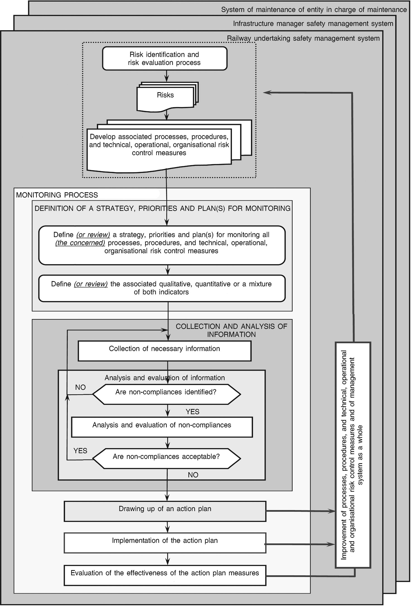
Evaluation of the effectiveness of the action plan measures

YES
YES
definition of a strategy, priorities and plan(s) for monitoring
MONITORING PROCESS
Improvement of processes, procedures and technical, operational and organisational risk control measures and of management system as a whole

Are non-compliances acceptable?
Implementation of the action plan
Drawing up of an action plan
Analysis and evaluation of non-compliances
Are non-compliances identified?
NO
NO

Analysis and evaluation of information
Colletion of necessary information
COLLECTION AND ANALYSIS OF INFORMATION
ДеDefine (or review) the associate qualitative, quantitative or a mixture of both indicators

Define (or review) a strategy, priorities and plan(s) for monitoring all (the concerned) processes, procedures, and technical, operational, organisational risk control measures

Develop associated processes, procedures, and technical, operational, organisational risk control measures
Risks
Risk identification and risk evaluation and risk evaluation process
Railway undertaking safety management system
Infrastructure manager safety management system
System of maintenance of entity in charge of maintenance

